**Practical 4: Chapter 6 Form**

**Section A:**

**Lab Exercise (Compulsory)**

Page : Practical 4 PDF-571 to 574 (Chapter 6 Form)

Exercise (s): Review Assignments

**Additional Lab Exercise (Optional)**

Page : Practical 4 PDF -574 to 576(Chapter 6 Form)

Exercise (s): Case Problem

**Section B:**

Question 1

Write the HTML code to create the form output as shown in Figure 1.

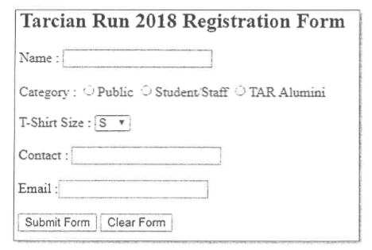

Figure 1

Specifications:

* Make the text "Tarcian Run 2018 Registration Form" as heading 2.
* Name the form as "run2018".
* "Name" field is a textbox.
* "Category" field consists of 3 radio buttons. Give them a group name called category with unique ids each.
* "T-Shirt Size" field is a selection list which consists of 4 options: S, M, L and XL**. [use <datalist> tag instead of the <select> tag to create selection list]**
* "Contact" field is a textbox.
* "Email" field is an email type field.
* "Submit Form" is a submit button.
* "Clear Form" is a reset button.

**[Note: Use <br/> instead of the table tag to create the form.]**